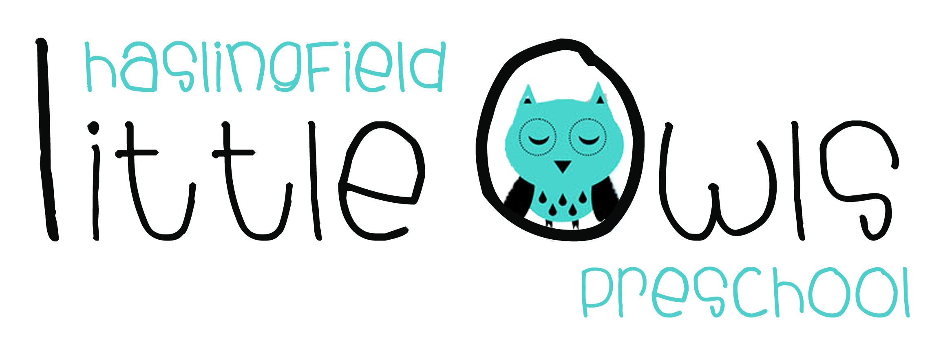
Application Form

Name of child: ___________________________________ Child’s date of birth: ___________________

Date of Application: ________________________________

Name/s and address/es of parent/s or carer/s making the application:
Home Tel: Mobile:

Email:

I/we are interested in our child attending Little Owls on the following days/sessions:
Session | MON | TUES | WEDS | THURS | FRI
9am-12 noon
12 noon-1pm | * | * | * | * | *
1pm-3pm | ** | ** | ** | Closed | Closed
Morning Sessions are 9am – 12 noon (minimum of 2 sessions) Afternoon Sessions are 1pm-3pm
*Lunch Club – 12 noon – 1pm available as an additional charge. **Not available for children that still require a sleep.

When would you like your child to start Little Owls?_______________________________
If your child currently attends another setting please state where and days: Setting:______________________________________ Days attending:____________________________

I/We would be able to visit at 9.30am on the following day(s)- please tick:
MON | TUES | WEDS | THURS | FRI

To secure a place on our waiting list, we require a non-refundable £50 administration fee per child. This does not guarantee you a place at the preschool. Please return the completed form, together with the £50 administration fee, to the Preschool Manager.
Please make cheques payable to Haslingfield Little Owls Preschool CIO or BACS to:
Account No. 24904924 Sort Code: 090129 with reference AdFee/(Surname of child).

We will confirm we have added your child to our waiting list by email once we have received both the completed Application Form and administration fee.

