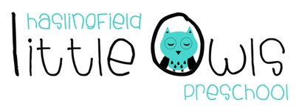

Week 11 Weekly Newsletter
26th November 2020
Dear Little Owls Families,

This week…
Little Owls have been celebrating thanksgiving with Laura this week. Thanksgiving is always the last Thursday of November, it marks the time when the native Americans and pilgrims feasted together to give thanks for the help the native Americans gave the settlers in the new world. Families and friends get together and have a huge feast with Turkey, Winter Squash, Potatoes, Corn, Beans etc. followed by pies, Pumpkin Pie, Apple and Pecan to name but a few. People stop and reflect and give thanks for many things. This is a big celebration where football is played, and decorations start to go up along with the Christmas season ahead - Thank you Laura S for telling us all about the meaning of Thanksgiving!

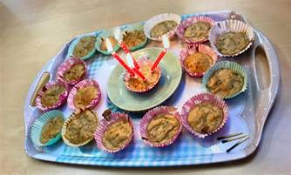
To celebrate Laura created lovely table decorations for the children to talk about and enjoy whilst eating their lunch and were trying the Thanksgiving Soup that we made. It was the most amazingly tasty soup and so many of the children (and Big Owls!!) ate the whole lot!
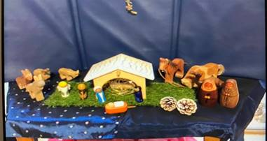
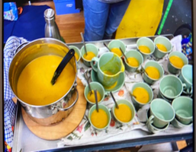

We also made birthday banana buns to celebrate Maisie’s 4th birthday and Maisie was able to blow out the candles on her own bun (covid-compliant!!).

Thank you!
We would like to thank all the families that brought in vegetables this week for our thanksgiving soup; it was much appreciated!

Also,
We have also been asked by some families for the ingredients in the thanksgiving soup:
- Butternut squash
- Potato
- Parsnip
- Carrot
- Apple
- Onion
- Garlic
- Celery
- Thyme
- Sage
- Allspice
- Nutmeg
- Veg stock cube

Next week...

ITS CHRISTMAS!!

We are going to start practicing our Nativity! How exciting!
Making Christmas Crafts, and reading Christmas stories!

Rainbow Rule...
This week we have been focusing on ‘kind words and kind hands’ as part of Thanksgiving. Next week we will be practicing our ‘walking feet and indoor voices’.

Birthdays...
We will be celebrating Emily’s 4th birthday this coming week. Happy birthday for Friday 27th November Emily! We will look forward to hearing all about your special day!

Little Owls Nativity
We were waiting to hear about current restrictions before confirming about our Nativity Performance this year. We are so pleased to announce that we are planning on doing this on the last day of term; Wednesday 16th December at 1pm in the garden! We will be doing this with just the Moonbeams for their parents/carer this year to limit numbers. We ask that the children bring a lunch that day and then we will get ready to start at 1pm. Please come as close to 1pm as possible to minimise time spent in the setting and observe social distancing rules at all time. All costumes and props will be provided.

Fundraising....

Lockdown Quiz 2.0 - Haslingfield School PTFA and Haslingfield Little Owls
If you would like to join in please email haslingfieldpubquiz@gmail.com before 7pm with your team name and we will send you your picture quizzes and further information. Everyone is welcome; friends, family, colleagues and grandparents, whether Haslingfield residents or not. Check out our Facebook event for more information https://www.facebook.com/events/702096233761235/

Tea Towel Orders
Orders need to be placed by this Tuesday, 1st December to arrive in time for Christmas.

Christmas Cards
Our Christmas cards are available to purchase again, they will be put outside with an honesty box where you can pop in your payment. Please adhere to social distancing when purchasing.

Black Friday
Please remember to use Amazon smile or easyfundraising when you are grabbing all those online Christmas Bargains!! If you pick Haslingfield Little Owls as your chosen charity we will receive a small percentage of your shop at no extra cost to you, every little bit helps!
https://smile.amazon.co.uk
https://www.easyfundraising.org.uk

Important information...
Coronavirus
Please be aware of the changes in the Government’s national restrictions, to stop the spread of coronavirus, that come into force on 2nd December. While dropping off or collecting your child from Little Owls please adhere to social distancing, using of hand gel and wearing a mask if within 2 metres of other adults. This is especially the case with our staff as some are in higher risk categories. Thank you.

Absence
If your child is unable to attend Little Owls because of illness, self isolation etc., please can you text the setting phone to notify us as soon as possible rather than email if possible. Julie is not in the office all the time so your email may be missed, thank you.

Lost Property…
One of our Little Owls is missing a pair of Navy Blue Muddy Puddles Waterproof Trousers aged 4-5 years. They are named but it is possible that the name tag has come loose. Please can you check your child’s belongings in case they have been sent home with you by mistake. Thank you!

Dates for your Diary
Tuesday 1st December: Last day to place your order for LO’s tea towels
Saturday 28th November: Lockdown Quiz 2.0 @ 8pm
Saturday 5th December: Methodist Church Christmas Market
Wednesday 16th December: Little Owls Nativity @ 1pm in the Garden
Last Day of Term: Wednesday 16th December 2020

We hope you have a lovely weekend, and we look forward to seeing you next week.

Best wishes from
Abby, Caroline, Charlotte, Julie, Laura, Lucy and Sobia
The Little Owls Team
07704 908109

