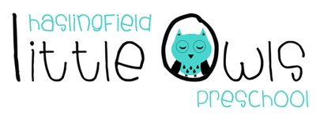

Week 9 Weekly Newsletter
12th November 2020
Dear Little Owls Families,

We hope you are all keeping well and safe and not finding the current COVID-19 restrictions too difficult.

This week…
We have been celebrating Diwali, the Hindu Festival of Lights. Our Little Owls have enjoyed making onion bhajis with Sobia, which were super Yummy! This gave the children the opportunity to explore the different textures of mixing the ingredients and tasting the flavour of the spices. This activity is great for exploring the science and mathematics that comes with cooking.
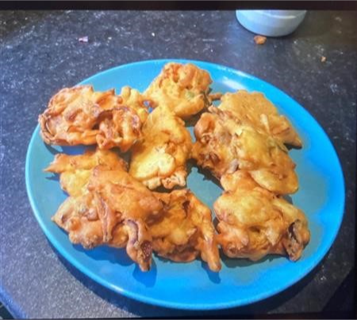

As part of the Diwali celebrations people decorate their houses with colourful Rangoli artworks, patterns created on the floor using coloured rice or powder. Our Little Owls explored different coloured rice and made different Rangoli patterns, the children loved transferring the rice into different pots and making sounds with the rice by sprinkling it on to the tray and into the glass bowls.
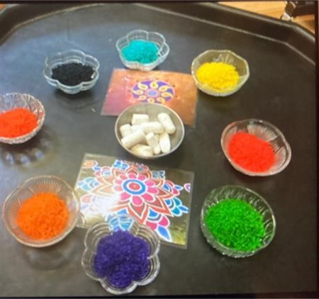

Sobia also shared her henna decorating with us and painted beautiful Rangoli patterns on our hands, the children really enjoyed this.
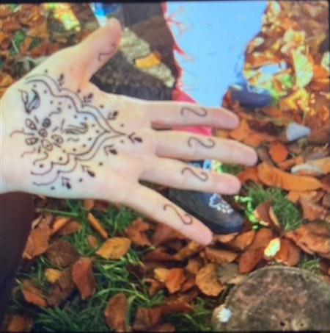

We also talked a lot about Remembrance Day during our together time, we read the book ‘where the poppies grow’ by Hilary Robinson. The children really enjoyed this book and sat nicely and used their listening ears.
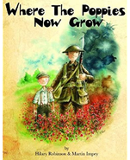

We also spoke about the fact that lots of people died to make our world a better place.

Next week...
We will be continuing our celebration of Diwali.

Songs
I am a Little Hedgehog
Autumn songs
Please remember to post photos of what you are doing with your children at home on Tapestry, it is a really good way for us to communicate with the children and to speak to them about what they have been up to while being at home

Fund Raising....

Nature Hunt
Thank you so much for all the nature hunt forms we’ve received so far, it’s lovely to see how many children have taken part. Thank you so much!!!

Please could all sponsorship make their way in by Wednesday the 18th of November.
We can accept cash in an envelope (marked with your child’s initials) or a bank transfer to:

Santander
Haslingfield Little Owls preschool CIO
Acct. 24904924
Sc. 09-01-29
Please use your child’s initials and nature hunt as the description.

We will then be able to let you know a total next week.
Again, thank you for helping your preschool in these very difficult times.
From Helen (Harry’s mummy)

Tea Towel Orders
Please keep an eye on your inbox in the coming days for the email to order your Little Owls tea towel. Time is limited for ordering in time for Christmas so don’t miss it!

Early Years Funding
Reminder! The deadline date to apply for extended hours and be entitled in Spring 2021, is December 31st. Please reconfirm your details with HMRC when required to keep your code valid.

Important information

Coronavirus
Further to last week’s request to wear face masks when dropping off or collecting your child we would like to clarify that this is not mandatory. However, we strongly recommend wearing a face mask if you will be within 2 metres of other adults, for example needing to hand over your child or belongings to staff. Thank you for your understanding.

Please be aware that you can form an informal childcare bubble with another household for childcare for children aged 13 or under. Please click on the link for the official guidance.
https://www.gov.uk/guidance/making-a-childcare-bubble-with-another-household

Please also be aware that during this lockdown individuals can meet one other person from another household outside in a public place and that children under school age do not count towards the two-person limit.

Door Bell
Please note that there is now a door bell for Little Owls, it is located on the closest entrance to the gate.

Dates for your Diary
Saturday 5th December: Methodist Church Christmas Market
Last Day of Term: Wednesday 16th December 2020

Have a lovely weekend and we look forward to seeing you next week.

Best wishes from
Abby, Caroline, Charlotte, Julie, Laura, Lucy and Sobia
The Little Owls Team
07704 908109

