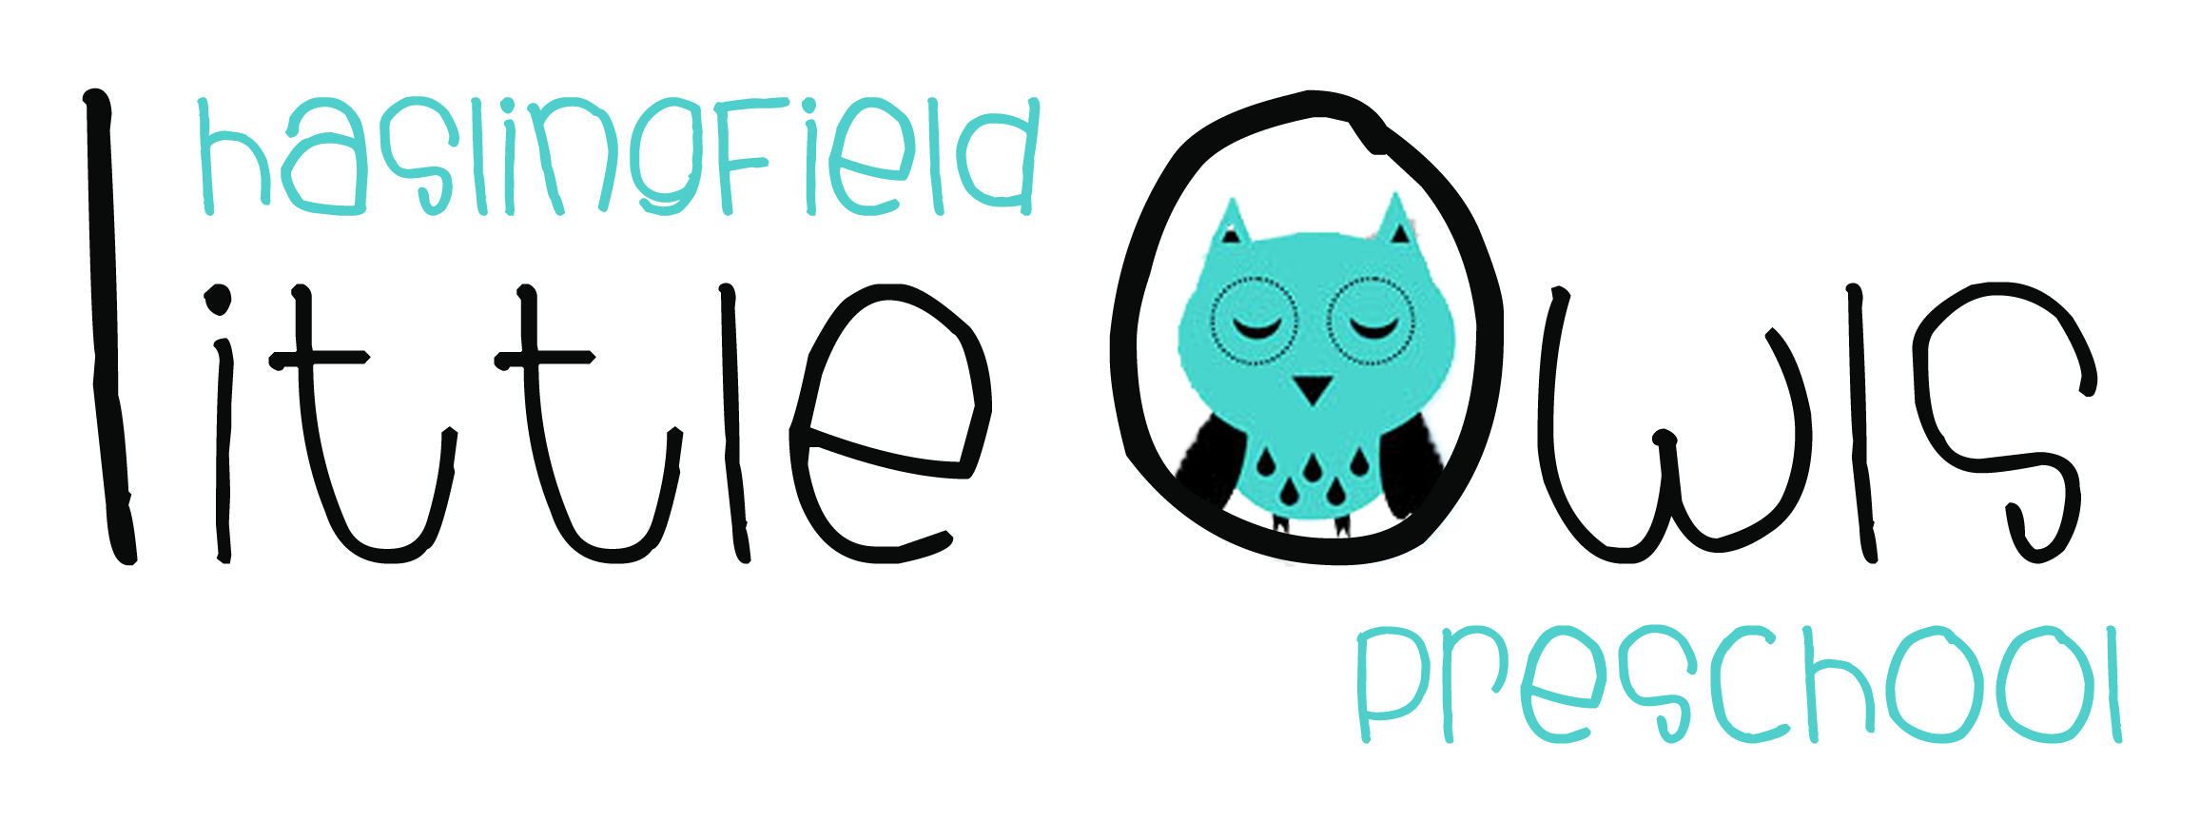
Application Form

Name of child: _____________________________________

Child’s date of birth: ________________________________

Date of Application: ________________________________

Name/s and address/es of parent/s or carer/s making the application:
Home Tel: Mob:

Email:

I/we are interested in our child attending Little Owls on the following days/sessions:
Session | MON | TUES | WEDS | THURS | FRI
9am-12 noon
12 noon-1pm |  |  |  | *
1pm - 3pm**
*Please note we close at 12 noon on a Thursday on luncheon club days (once every 3 weeks)
**Please note this session also needs to include 12 noon-1pm

When would you like your child to start Little Owls?_______________________________

I/we would be able to visit at 9.30am on the following day(s)- please tick:
MON | TUES | WEDS | THURS

