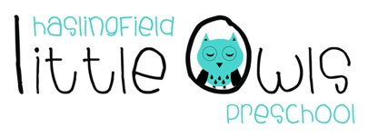
Weekly Newsletter
5th January 2020
Dear Little Owls Parents and carers

Our first newsletter of 2020, albeit brief!

First day of term is tomorrow, Monday 6th January. We are looking forward to seeing everyone this coming week and we hope you had a lovely Christmas and a Happy New Year to you all.

Thank you!
A big big thank you for all the lovely Christmas gifts, cards and beautiful hampers you so generously and thoughtfully gave, we are all very appreciative.

This week
Birthdays…
We will be celebrating birthdays of Emily C, Iris, Jack and staff member Caroline, all who celebrated their birthdays over the Christmas holidays.

Rotas
This term we will no longer ask you to bring fruit in for snack time. We will be purchasing the fruit ourselves as we realise asking you to provide fruit is not always convenient and puts extra pressure on families. If you would like to make a voluntary contribution towards the purchase of fruit we suggest 25p per day per child. Please can any contribution be made in cash and at the beginning of each half term so that we can take a small group of children to the shop each week to select and purchase fruit for everyone. Thank you.

Important information

Illness
If you child is unwell or unable to attend Little Owls, please remember to notify us early morning. It is very important that you that you do this every day your child is unable to attend.

Chickenpox
There has been an outbreak of Chickenpox for some children that attend Little Owls. If your child has or develops the symptoms of Chickenpox it is important that you keep your child as home until the last spot has scabbed. While the spots have fluid they are infectious. If you require any further information on infectious diseases please email Julie and she will send you the government guidance the preschool follows.

Reminder!
As the weather is still cold and wet and snow is forecast for the coming weeks, please make sure that your child comes to preschool with a warm coat, waterproofs and wellington boots. Outdoor play is very important to the children so please can your child have a change of clothing in a bag on their peg. All items to be named. On your child’s last session each week, please take all belongings home with you as we need to pack away everything at the end of Thursday’s session.

We hope you have a great week!

Best wishes from
Abby, Kayleigh, Sobia, Hayley, Caroline, Sophie, Charlotte and Julie
The Little Owls Team
07704 908109

