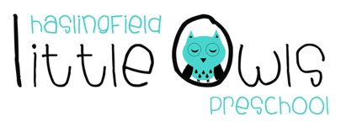
Weekly Newsletter
21st November 2019
Dear Little Owls Parents and Carers,

This week

The Autumn leaves are falling down so the children have been raking, gathering, throwing and making nests.

They were also very excited to see that Jack Frost has visited. The children used the following words to describe the frost.

‘Magical, Sparkles, Crunchy, Crispy, Icy’

We also introduce the Nativity story to our together time, which some of the Moonbeams could remember from last year.

Next week

Together Time - Thanksgiving and Nativity

On Wednesday David and Jessica’s Mummy is joining us to share their family festival of Thanksgiving. Throughout the week we will be sharing the Thanksgiving story with the children and discussing giving thanks and what we are grateful for.

We will also be continuing with our Nativity story and songs.

Birthdays

On Thursday we will be celebrating Maisie’s 4th Birthday
We will be celebrating Emily B’s birthday the following week due to Thanksgiving.

Key Text
Shooting Stars - That’s not my Pirate

Rainbow rule
We listen to each other.

Rotas for next week please
Week beginning |  | Fruit | Beginning (Mon/Tue) | Middle (Wed/Thu) | Washing Bag
 | 25th Nov | 8 Bananas each  8 Apples each  8 Pears each  8 Satsumas each | -Jessie L  -Clara  -Emily Ch  -Joey | -David  -Jessica S  -Iris  -Jess G | Noah (Thu)
 | 2nd Dec | 8 Bananas each  8 Apples each  8 Pears each  8 Satsumas each | -William  -Sen  -Noah  -Wilfred | -  -Maisie  -Alex  -Elliot | Elliot (Tue)

Important information

Nativity Invitation

You should have received your invitation for our Christmas Nativity by email, please let Julie know if you have not received yours.

We hope you enjoy your weekend and we look forward to seeing you all next week!

Best wishes from
Abby, Kayleigh, Sobia, Hayley and Julie
The Little Owls Team
07704 908109

