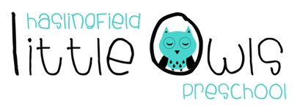
Weekly Newsletter
31st October 2019
Dear Little Owls Parents and Carers,

This week….
Welcome to Alice and her family who started on Monday as one of our Comets! Our Together Time song this week was 5 Little Pumpkins. For book time all our children read ‘Meg and Mog’ which is all about a spell that goes wrong. It has lots of noises that the children enjoyed joining in with which helps their pre-phoincs skills (phonological awareness).

Next week…
We are going to be sharing our experiences of Fireworks night so please upload any photos to Tapestry that we can share with the children.
Together Time song: Remember, Remember the 5th of November
Moonbeams focus book: The story of Guy Fawkes
Shooting Stars and Comets focus book: Owls Babies
Rainbow Rule of the week: Everyone is Welcome

Rotas
Rotas for next week please:
Week beginning | Fruit | Beginning (Mon/Tue) | Middle (Wed/Thu) | Washing Bag
HALF TERM
4th Nov | 8 Bananas each  8 Apples each  8 Pears each  8 Satsumas each | -Clara  -David  -Jessica S  -Jessie L | -Joey  -Jess G  -Edmund  -Maisie | Emily Ch and James (Tue)
11th Nov | 8 Bananas each  8 Apples each  8 Pears each  8 Satsumas each | -Sen  -Alice  -James (Mon)  -William | -Alex  -Emily Co  -Emily B  -Noah | Clara (Wed)

We hope you enjoy your weekend and we will look forward to seeing you all next week!

Best wishes from
Abby, Kayleigh, Sobia, Hayley, Natalie and Julie
The Little Owls Team
07704 908109

