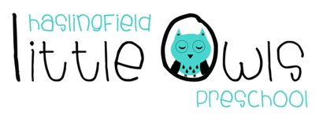
Weekly Newsletter
17th October 2019
Dear Little Owls Parents and Carers,

This week….
Our Together Time song this week was Twinkle, Twinkle Little Star to support our Diwali celebrations. For book time the Moonbeams (rising 4s) read the Diwali Story about Rama, Sita, Ravana and Hanuman. We clapped each of their names to see how many syllables were in each one. Our Shooting Stars (rising 3s) and Comets (2 year olds) read ‘Kitten Learns to Listen’ and talked about what a good listener does. We have done lots of investigating with rice this week and about Diwali lamps, making some with our playdough.

Next week…
Please remember this Thursday 17th October was the last day of this half term. Little Owls will then reopen Monday 28th October.

Rotas
Rotas for the next week please:
Week beginning | Fruit | Beginning (Mon/Tue) | Middle (Wed/Thu) | Washing Bag
HALF TERM
28th Oct | 8 Bananas each  8 Apples each  8 Pears each  8 Satsumas each | -Elliot  -Tom (Mon)  -Hattie  -Emily Ch | -Freddie  -Jameson  -Jack  -Iris | Maisie (Thu)
4th Nov | 8 Bananas each  8 Apples each  8 Pears each  8 Satsumas each | -Clara  -David  -Jessica S  -Jessie L | -Joey  -Jess G  -Edmund  -Maisie | Emily Ch and James (Tue)

Staffing
Please note that after half term Kayleigh will be working on Thursdays instead of Sobia. Sobia was doing this extra day for the first half term whilst Kayleigh and Jameson settled in. Key children will not be affected.

We hope you enjoy your weekend and half term break and we will look forward to seeing you all the following week!

Best wishes from
Abby, Kayleigh, Sobia, Hayley, Natalie and Julie
The Little Owls Team
07704 908109

