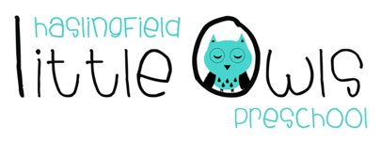
Weekly Newsletter
12th September 2019
Dear Little Owls Parents and Carers,

Welcome!
We have welcomed lots of new children and their families to Little Owls this week and our current Little Owls have been very excited to make new friends. Welcome to Jess, Alex, Joey, Aryan, Jameson, Tom and Edmund. The children (and all the parents and carers!) have also been so welcoming to our new staff, Kayleigh and Natalie for which they ae very grateful!

This week….
We have had a very exciting first week back, celebrating Clara’s 3rd birthday, that was during the holidays, and also William’s 4th birthday. Happy birthday to you both! We also harvested our potatoes…the children (and staff!) had so much fun finding them!

During our Together Time we sang 5 Little Speckled Frogs (with our gorgeous hand-made frogs, log and pond!) and Twinkle, Twinkle Little Star. For book time the Moonbeams (rising 4s) read ‘We are Family’ by Patricia Hegarty which includes a variety of different family units from around the world. Our Shooting Stars (rising 3s) and Comets (2 year olds) read a variety of our key books, such as ‘Goat Goes to Playgroup’, ‘Toddle Waddle’ and ‘That’s Not My’ books.

Next week…
Monday will be bread day! This rotates every week so all children have a chance to do this during the term. Our focus Together Time songs will be 5 Little Ducks (we change ‘Mummy Duck’ to different family members each time) and Wind the Bobbin up. Please keep sending in photos of your child and their families for our display.

Internet
Unfortunately, we currently have no internet at Little Owls. As you can imagine this has had a huge impact on us, especially at the start of a new academic year. This has meant that we are really struggling to upload to Tapestry and check emails, amongst other things. We are hoping this will be resolved very soon.

Rotas
Rotas for next week please:
Week beginning | Fruit | Beginning (Mon/Tue) | Middle (Wed/Thu) | Washing Bag
16th Sep | 8 Bananas each  8 Apples each  8 Pears each  8 Satsumas each | Hattie  Tom (Mon)  Elliot  Sen | Emily Co  Alex  Emily B  William | Hattie and Tom  (Thu)
23rd Sep | 8 Bananas each  8 Apples each  8 Pears each  8 Satsumas each | Joey  Freddie  Jameson  Wilfred | Jack  Jessie L  Iris  Clara | Emily Co  (Wed)

Home Support
We have had lots of requests from parents/carers about how best to approach behaviour with children. We very much appreciate there are so many different views on this so we have attached some tried and tested techniques from an amazing website called https://www.babycentre.co.uk/ that has so much amazing advice for those who are interested. This very much reflects what we do at Little Owls. Behaviour is definitely one of the hardest parts of parenting and childcare!
Some books we would recommend are:
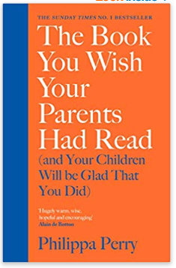and 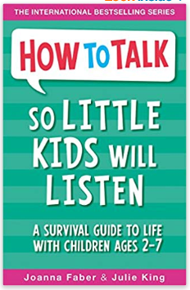
Philippa Perry will be at the Cambridge Literary Festival on 29th November! You can book tickets online at: http://www.cambridgeliteraryfestival.com/whatson/philippa-perry/
We strongly encourage you to come and talk to your child’s key person if you have any questions or queries about your child. Either catch them at drop off or pick up, make an appointment directly with them or email Julie to make an appointment. If we don’t have to answers ourselves we will do our best to find out for you!

We hope you enjoy your weekend and we will look forward to seeing you all next week!

Best wishes from
Abby, Kayleigh, Sobia, Hayley, Natalie and Julie
The Little Owls Team
07704 908109

