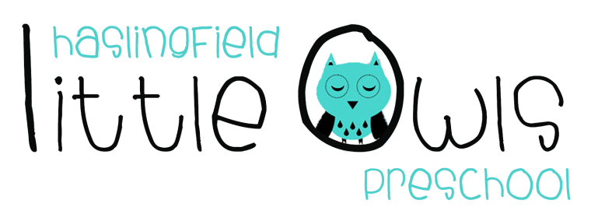

Job description: Level 3 - Early Years Practitioner

Job title: Early Years Practitioner (Level 3)

Responsible to: Manager

Purpose of the job: To work as a key person and as part of the pre-school team under the direction of the manager. To provide safe, high quality education and care for young children which meets the individual needs of children attending the setting.

Job details: The role is based in Haslingfield at our welcoming, not-for-profit preschool in the heart of the village. We need a person to join us after February half term for the remainder of the academic year (to July 2019). This is a fixed term contract for 4-5 mornings per week (approximately 20-25 hours per week, days to be discussed), term time only. There could be scope to move this to a permanent contract at the end of the academic year. Flexibility to work overtime would be welcomed. Rates of pay available on request.

Safeguarding requirement: Haslingfield Little Owls Preschool is committed to safeguarding and promoting the welfare of children and young people. It is a requirement of all staff that they share this commitment and follow the prescribed policy and procedures to continuously promote a culture of safeguarding across the whole organisation.

Main duties

- To assist with the planning and delivery of the curriculum using the Early Years Foundation Stage (EYFS) for guidance.

- To create an inspiring and engaging learning environment for our children.

- To help to set up for the daily programme and to help tidy away at the end of the session.

- To act as a key person to a small group of children, liaising closely and building an effective relationship with parents/carers and ensuring each child’s needs are recognised and met.

- To work in partnership with parents/carers and other family members.

- To advise the Manager of any concerns, e.g. health and well-being of children, parents or the safety of equipment, preserving confidentiality as necessary.

- To take action to support the setting to achieve and maintain a minimum good Ofsted rating at the next inspection.

- To teach children, offering an appropriate level of support and stimulating play experiences.

- To ensure that children are kept safe and that you understand when to follow child protection procedures.

- To support meal times within the setting.

- To actively participate at team meetings, supervision meetings and appraisal meetings.

- To attend training courses as required and to take responsibility for personal development.

- To keep completely confidential any information regarding the children, their families or other staff, which is acquired as part of the job.

- To be aware of and adhere to all the setting’s policies and procedures including those relating to confidentiality, equality and diversity, health and safety, fire precautions, dropping off and collection of children, food safety, cleanliness of the setting, safeguarding, setting hygiene and whistleblowing. This is not an exhaustive list of the setting’s procedures.

- To ensure that adequate records are kept and updated regularly.

- To promote the setting to current parents and potential customers.

- To comply with the requirements of the General Data Protection Regulation.

This job description is not an exhaustive list of duties and the post holder will be required to undertake any other reasonable duties discussed and directed by the line manager. The post holder is also expected to be flexible and adaptable in their approach to fulfilling their duties.

Person specification

Essential criteria

- Willingness to learn and undertake further training.

- Level 3 early years education and childcare qualification or equivalent.

- Previous experience of working with young children.

- Sound proven knowledge of child development from birth to five years.

- Knowledge of, and evidence of the use of the Early Years Foundation Stage (EYFS) including planning in the moment, and reflective practice.

- Demonstrates knowledge and appreciation of safeguarding and child protection procedures and interprets those procedures correctly.

- Excellent communication skills.

- A demonstrable understanding of play-based approaches to children’s learning and development.

- A proven commitment to continuously promote a culture of safeguarding.

- A commitment to equal opportunities.

- A commitment to working effectively with young children and families.

- A friendly and flexible approach at work which facilitates the development of effective relationships.

Desirable criteria

- Current First Aid at Work qualification.

- Experience of using Tapestry.

- Experience of forest school.

- An understanding of heuristic play.

- A strong understanding of how to best manage children’s behaviour.

This post is exempt from the Rehabilitation of Offenders Act (1974) and does require an enhanced Disclosure and Barring Service Check. Applicants must be prepared to disclose any convictions they may have and any orders which have been made against them.

For an application form, please contact: chair@haslingfieldlittleowls.org.uk

